The Research Process: Start with Questions (Inquiry)
from https://sites.google.com/site/wrdsbresearchandinquiryplan/home/rationale-2
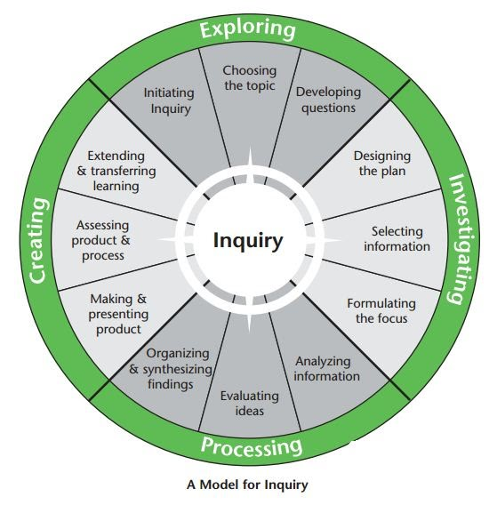
Conducting Primary Research Online: A Primer
- Start by writing your research question(s) for the overall research topic.
- Which research questions can best be answered with primary research?
- Categorize your primary research as interview, survey, or observation.
- Determine if the primary research is possible in person, online, or both.

Online Survey | Online Interview | Online Observation
SurveyMonkey.com | E-mail | Audience Analysis
Google Forms | Twitter | Reception Studies
Facebook/Twitter Polls | Facebook/Twitter Expert Interviews | Online Text/Content Analysis. For example:  Voyant-Tools.org
Texting/Apps/Forums | Video/FaceTime/Skype
Background: What Is a Reception Study?
In Chapter 8 of RAAWr, you read about the importance of the “user experience” of a product or document. You also read about usability testing, protocol analysis, focus groups, interviews, and surveys as methods to learn how users feel about a product or document. All of these are valuable tools that could be used as part of Project 3.
However, you have another primary research method available for Project 3 called a “reception study.” A reception study is a type of observation that involves the collection and analysis of discourse (often text, but also images, emoji, etc.) that real users have written or produced about their experience or opinion of something. Harris (2005) and Ceccarelli (2005) have each argued for the importance of reception studies in understanding how actual users, not ideal or imagined users, experience the world.

In academic research, reception studies are used to learn how “real” audiences have written about literature, film, media, science, technology, and products and services. In Project 3, you may design and complete a reception study to better understand what real users or audiences have posted online about your research problem, which is likely a product, service, or situation. The steps below are intended to guide you through the collection and analysis of online texts as part of a reception study using Voyant Tools.
A Brief Guide to Using Voyant Tools to Analyze Text
- Begin by brainstorming where you could look for online reviews, comments, posts, or feedback about your research problem for Project 3.
  - Consider Google Reviews, Yelp, Bing Reviews, Comments Sections, Online Forums, Twitter Hashtags, Facebook Reviews, etc.
- Take a brief look at each of the locations you have brainstormed above.
  - Note the number of total reviews, ratings, or feedback posts. Are there enough?
  - Note what type of reviews, ratings, or feedback is posted. Do they include text?
- Select from the options above or select a combination from the above options.
  - Which source(s) of audience reception is/are most representative?
  - Which source(s) has/have enough responses to analyze and interpret?
  - How old or new are the posts on the sources, or how long do they span?
- Copy ALL of the selected user comments/reviews and paste them into a separate file.
- “Clean the data”: remove usernames and label information such as “stars” or “date.”
- Copy and paste the entirety of your “cleaned” text into Voyant-Tools.org and “Reveal.”
- Use the “context,” “correlations,” and “document terms” options to suggest relationships between users’ comments based on words and phrases.
- Analyze how the use of words and phrases in user comments informs your understanding of the research problem in Project 3.

